**Public Broadcast Profile**

Purpose：

enable a faster, more efficient discovery of Broadcast Sources that are transmitting audio

with commonly used codec configurations

Public Broadcast Profile (PBP) defines a Public Broadcast Announcement

1. a Broadcast Source is in an extended advertisement. And the Broadcast source is transmitting:

* A broadcast Audio Stream with a configuration that every BAP(Basic Audio Profile) Broadcast Sink can receive and decode (Standard Quality Public Broadcast Audio)
* A broadcast Audio Stream that uses a High Quality Public Broadcast Audio Stream configuration

1. indicates whether the broadcast Audio Streams in the Broadcast Isochronous Group (BIG) are encrypted or not

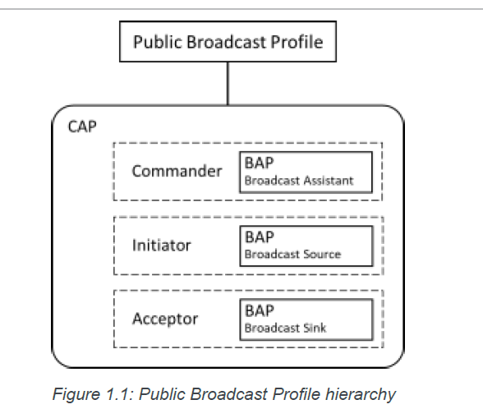

Roles

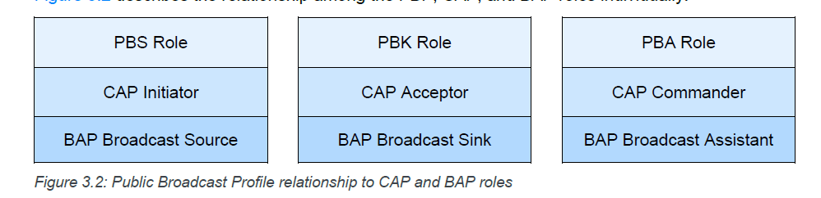

Through CAP(Common Audio Profile), a PBS(Public Broadcast source) supports the BAP Broadcast Source role, a PBK(**Public Broadcast Sink**) supports the BAP Broadcast Sink role, and the PBA(**Public Broadcast Assistant**) supports the BAP Broadcast Assistant role

**Public Broadcast Source (PBS): CAP initiator**

The PBS indicates when Standard Quality, High Quality, and encrypted public broadcast Audio Streams are broadcast.

It is recommended that a PBS transmit Program_Info metadata. A PBS uses the

Encrypted Broadcast Source feature of CAP when an encrypted stream is provided.

The PBS also provides a Broadcast Name AD type for the corresponding BIG that can be used to identify the broadcast to an end user.

**Requirement**

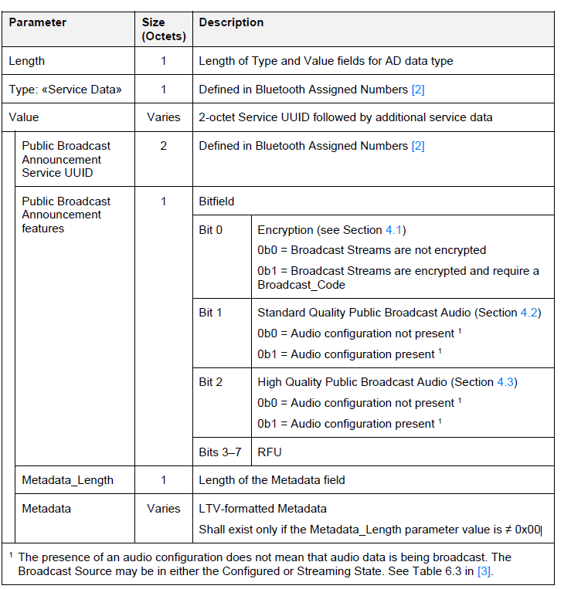

The Broadcast_Name AD Type allows an Isochronous Broadcaster to assign a human-readable string to a BIG.

The Broadcast_Name string can be used by a user interface on a scanning device that displays information on the available broadcast sources.

Multiple Isochronous Broadcasters can assign a common Broadcast_Name to BIGs that are transmitting the same data, allowing a scanning device to identify alternative Isochronous Broadcasters providing the same data.

Broadcast Name Data AD Type format

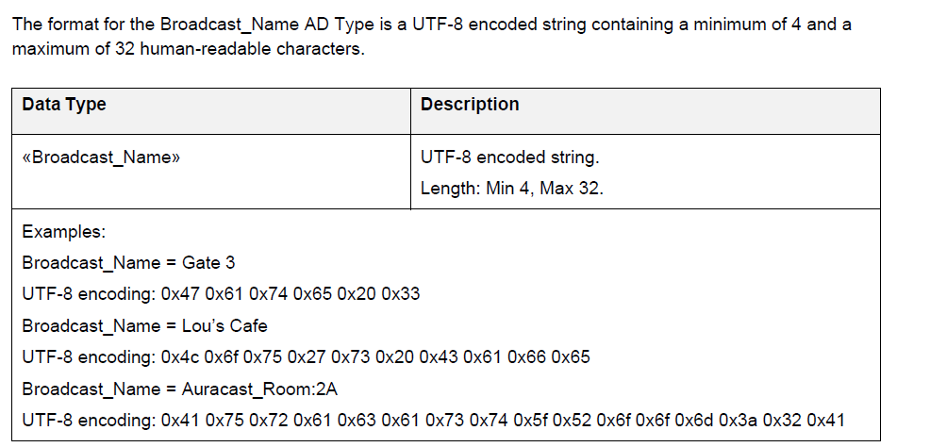

Standard Quality Public Broadcast Audio

0b1 means the advertising set used to transmit the Public Broadcast Announcement points to a BIG, which shall include at least one broadcast Audio Stream configuration defined as Mandatory for a Broadcast Sink

High Quality Public Broadcast Audio

High Quality Public Broadcast Audio in this specification means broadcast Audio Streams configured with any one of the broadcast Audio Stream configuration settings listed in below table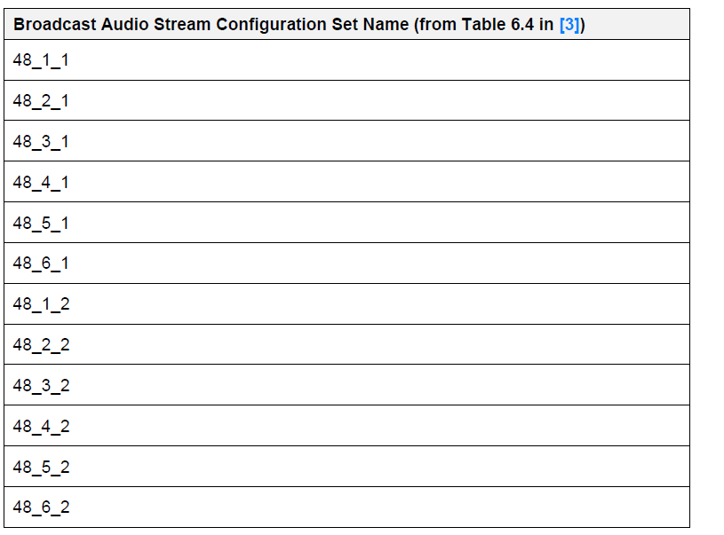

**Public Broadcast Sink (PBK): CAP acceptor**

A PBK may perform the BAP Basic Audio Announcement discovery to discover the presence of a Public Broadcast Announcement.

**Public Broadcast Assistant (PBA): BAP broadcast Assistant** controls the reception of a broadcast Audio Stream that is associated with a Public Broadcast Announcement.

A PBA may perform the BAP Basic Audio Announcement discovery to discover the presence of a Public Broadcast Announcement.

PBP Test Suite

The test objectives are to verify the functionality of the Public Broadcast Profile Specification within a Bluetooth Host and enable interoperability between Bluetooth Hosts on different devices.

Implementation Under Test (IUT) is the tested Bluetooth stack running on a device.

A Lower Tester acts as the IUT’s peer device and interacts with the IUT over-the-air interface.

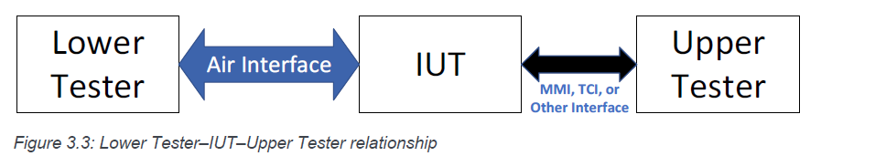

This Test Suite contains Valid Behavior (BV) tests and Invalid Behavior (BI) tests

Test Groups:

Public Broadcast Metadata

**PBP/PBS/PBM/BV-01-I [Transmit Program_Info Metadata]**

Verify that an IUT can transmit Public Broadcast Metadata.

* Initial Condition
  + - The Lower Tester is a PBK.
    - TSPX_Program_Info is the Program_Info metadata defined in IXIT.
    - TSPX_PA_Interval is the periodic advertising interval of the periodic advertising associated with the IUT’s BIG as specified in IXIT.
* Test Procedure
  + The Upper Tester commands the IUT to begin broadcasting and includes the metadata specified in TSPX_Program_Info in the BASE (the Broadcast Audio Source Endpoint of the Basic Audio Announcement) as the Program_Info LTV.
* Expected Outcome

Pass verdict

The IUT’s broadcast LTV Public Broadcast Program_Info metadata in the Basic Audio Announcement matches TSPX_Program_Info.

Public Broadcast Streaming

Verify that an IUT can correctly transmit the Public Broadcast Announcement and meet the requirements for Standard Quality and High Quality audio with encryption if supported.

Standard Quality Streaming Support- PBS

* Test Purpose

Verify that the PBS IUT correctly transmits Public Broadcast Audio Announcements for Standard Quality and includes one BIS in the BIG configured using BAP 16_2_1, 16_2_2, 24_2_1, or 24_2_2 QoS settings.

* Initial Condition
  + - The Lower Tester is a PBK.
    - TSPX_Program_Info is the Program_Info metadata defined in IXIT.
    - TSPX_PA_Interval is the periodic advertising interval of the periodic advertising associated with the IUT’s BIG as specified in IXIT.
  + Test case configuration
    - PBP/PBS/STR/BV-01-I
    - PBP/PBS/STR/BV-05-I
    - PBP/PBS/STR/BV-06-I
    - PBP/PBS/STR/BV-07-I
  + Test Procedure
    - The Upper Tester orders the IUT to broadcast an unencrypted, Standard Quality broadcast Audio
    - Stream using the QoS Setting specified.
    - The IUT begins advertising the Public Broadcast Announcement, as well as broadcasting its Standard Quality broadcast Audio Stream.
    - The Lower Tester synchronizes to the broadcast Audio Stream established by the IUT.
  + Expected Outcome
    - The IUT correctly transmits the Public Broadcast Announcement with the PBP features bitfield value
    - set as follows:
      1. ▪ Encryption: 0b0
      2. ▪ Standard Quality Public Broadcast Audio: 0b1
      3. ▪ High Quality Public Broadcast Audio: 0b0
      4. ▪ RFU: All bits set to 0b0
    - The BIG QoS setting matches the QoS Setting.
    - The advertised Broadcast Name matches TSPX_Broadcast_Name.
    - Public Broadcast Announcements, Broadcast Audio Announcements, and Broadcast Name
    - advertisements arrive in the same Extended Advertising Report on the Lower Tester.
    - The BIG is unencrypted.

Receiving Public Broadcast Announcements

* PBK receives Public Broadcast Announcements

Verify that the PBK IUT receives Public Broadcast Announcements and Broadcast Name and can synchronize to the associated Standard Quality audio stream.

* PBA receives Public Broadcast Announcements

Verify that a PBA IUT receives Public Broadcast Announcements and Broadcast Name, even if RFU bits are set to 0b1.

Test Cases(TC):

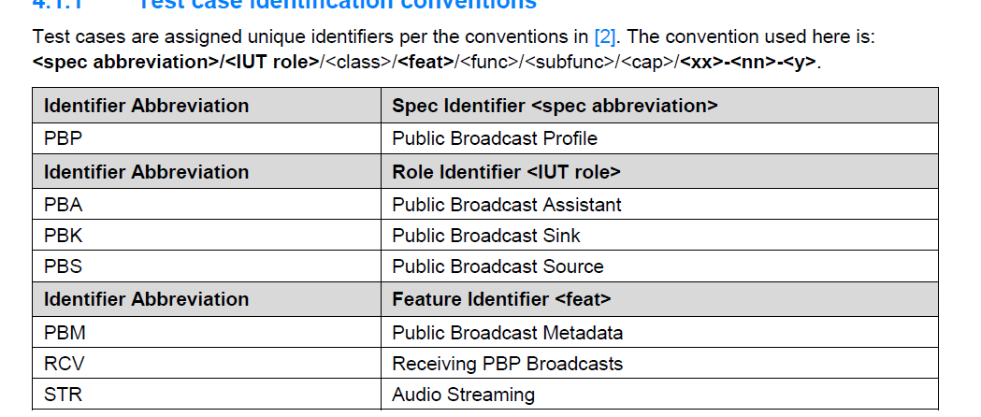

PBP ICS(Implementation Conformance Statement) – Define PBP Roles and features

